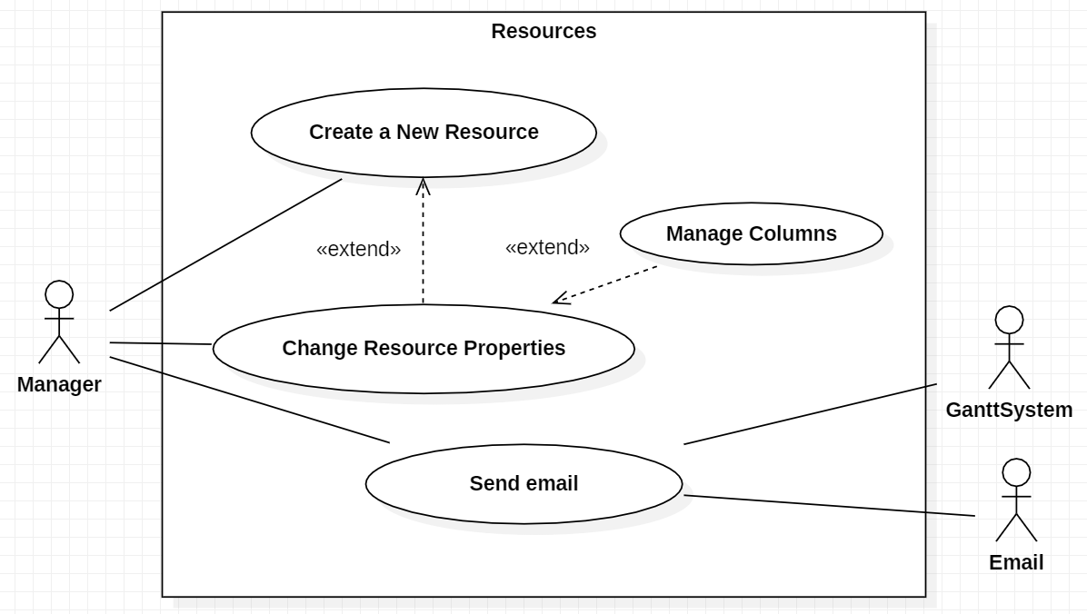**Resources Use Case**

Create New Resource

Pre-condition: None

Creates a new Resource and add it to the resource list.

The use case starts when the Manager clicks the add resource button.

In the resource creation, the Manager needs to add a name, a phone, a mail, a payment rate and select a default role.

The resource can be created with days off.

Pos-condition: None

Primary Actors:

• Manager.

Secondary Actors:

• None.

Change Resource Properties

Pre-condition: At least one resource exists.

The use case starts when the Manager clicks the resource properties button.

Change the properties of selected Resource in the resource list.

The Manager can change the name, phone, mail, payment rate and default role of any resource.

The Manager can also change the days off the resource has.

Pos-condition: None

Primary Actors:

• Manager.

Secondary Actors:

• None.

Send Email

Pre-condition: At least one resource exists.

The use case starts when the Manager clicks the send email button.

The Manager, using the System and the Help of the Email subsystem, sends an email to the selected Resource mail.

Pos-condition: None

Primary Actors:

• Manager.

Secondary Actors:

• GanttSystem, Email.

Manage Columns

Pre-condition: None

The use case starts when the Manager goes to the change properties and opens the manage columns tab.

The Manager can now manage the columns to be presented in the resource list.

Pos-condition: None

Primary Actors:

• Manager.

Secondary Actors:

• None.